**Aaquib Badarpura**

Data Scientist

Aaquibbadarpura780@gmail.com | 7778010445 | Ahmedabad, Gujarat | [LinkedIn](https://www.linkedin.com/in/aaquibbadarpura)  | [GitHu](https://github.com/Aaquib7860)[b](https://github.com/irbaz786)



Certified by Greekforgeeks | Completed 76% of a Comprehensive 1-Year Course

I am dedicated to leveraging data-driven insights to drive innovation, enhance decision-making processes, and solve complex challenges within a dynamic and collaborative environment.



# Silver Oak University 2021 – 2024 | Ahmedabad

**BCA** Average CGPA**: 9.91**



# [Machine Le](https://yhills.com/)arning Developer

* I create a system Architecture of Indian Currency Recognition for this company.
* Skills used – Jupyter Notebook, Deep Learning, OpenCV, Python, Kaggle



# Money Detection using Deep Learning and Text-to-Speech! April 2024 – April 2024

* Objective: I developed a deep learning model to detect currency notes in images. Leveraging the power of machine learning, I aimed to create a tool that can identify different denominations of currency accurately.
* Tech Stack: Python, TensorFlow, joblib, pygame, gTTS.
* Key Features: Utilized a pre-trained deep learning model to recognize currency notes. Implemented Textto-Speech functionality to announce the denomination of the detected currency. Achieved reliable results with high accuracy.
* Demo: Attached is a snippet of the code showcasing the model in action. It takes an image of a currency note as input and outputs the detected denomination, followed by an auditory announcement using gTTS and pygame.
* Impact: This project has practical applications in various domains, including assistive technology for visually impaired individuals, automated teller machines (ATMs), and counterfeit detection systems. Excited to continue exploring the intersection of machine learning and re

# Skills used - Python, TensorFlow, Machine Learning, Deep Learning, Text to speech

[**Scraping Bot!**](https://noun-data-aman78600.streamlit.app/)  February 2024 – February 2024

* About: Scraping Bot is a web scraping chatbot developed using Python. It allows users to input text, which triggers web scraping functionality to fetch and display relevant text data from the web. Whether you're retrieving information and any other text-based content. Scraping Bot is here to streamline your web scraping tasks!
* Features: Built with Python for efficient web scraping. Enables users to input text and receive real-time web scraping results. Seamless integration with popular web scraping libraries like Beautiful Soup and Scrapy.
* Why Scraping Bot? Whether you're a data enthusiast seeking to gather information from the web. Scraping Bot offers a user-friendly solution.

# Skills used - Web scraping, Web Development, Python, Streamlit

[**GDP Analysis Web App!**](https://gdp-app-amanshah.streamlit.app/)  February 2024 – February 2024

* About: This web application is the power of Python, Pandas, Plotly and Streamlit to create an intuitive platform for exploring and analyzing GDP data from across the globe. The goal behind this project was to democratize access to economic data and make GDP analysis more engaging and insightful for researchers, economists, students, and curious minds alike.
* Key Features: Interactive Visualization: Dive deep into GDP trends with dynamic and interactive charts that bring the data to life.
* Customizable Analysis: Select specific indicators and time frames to analyze, empowering users to uncover trends and insights tailored to their interests.
* Country Comparison: Compare GDP performance between countries, allowing for meaningful insights into economic dynamics on a global scale.

# Skills used - Pandas, Data Visualization, Web Development, Python

**Heart Disease Prediction Web Application** February 2024 – February 2024

* Heart Disease Prediction Web Application Objective Developed a web application to predict the likelihood of heart disease based on user input. Technologies Python: - Implemented the backend logic and machine learning model.
* Streamlit: - Created an interactive user interface.
* Machine Learning Algorithms: - Utilized logistic regression (or other suitable algorithms) for prediction. Key Contributions Trained a machine learning model using historical heart disease data. Engineered relevant features (e.g., age, blood pressure, cholesterol levels). Designed an intuitive web interface for users to input health information. Deployed the application for real-time predictions.
* Results: Achieved accurate heart disease predictions with an easy-to-use interface.

**Skills used – Python, Machine Learning, Python Web Framework.**

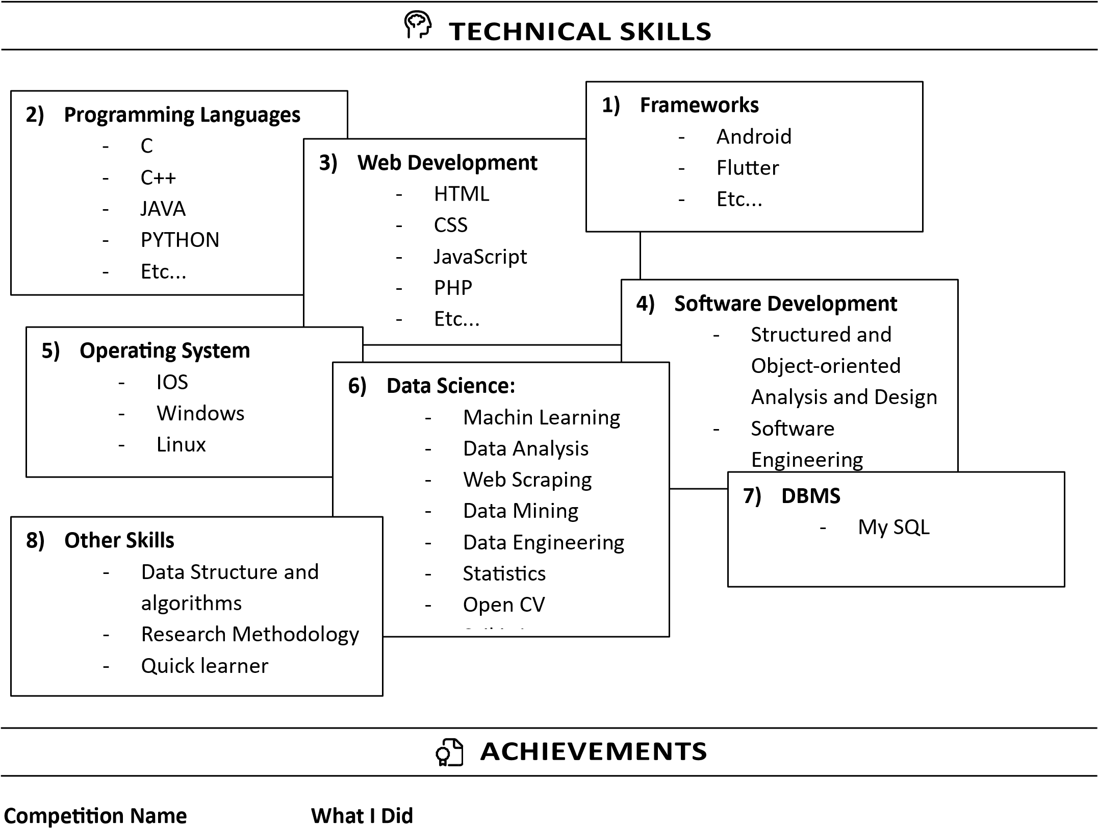

Ml Thone Hart Disease Prediction 2nd Prize 

Machin Learning TALAASH Analytical Tasks 2nd Prize

Aaviskar Indian Currency Recognition 1st prize



Aaviskar

Chatbot

3

rd

Pri

z

e